Creation of batchfile(.command) file in mac

- Navigate to http://www.barebones.com/products/textwrangler/download.html

- Click on 'Download' beside MAC related option ,it downloads related .dmg

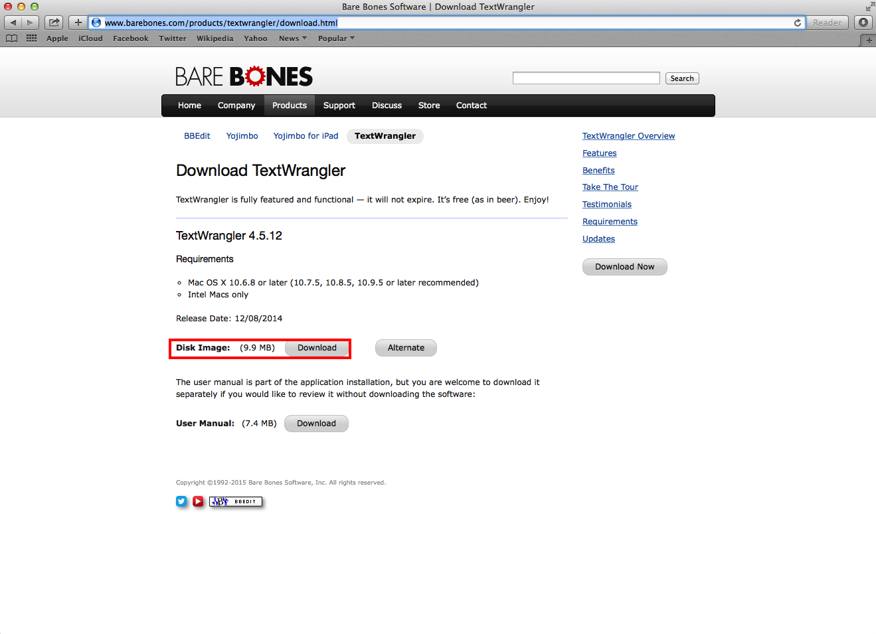

- After installation of text wrangler is done, launch it.

- Type bash commands say , for execution of build.xml(location is on desktop) using ant
cd Desktop
ant

- Save the file with extension as '.command' say, ant.command

- Now double click the ant.command file , it starts the execution of build.xml
